Florida Bright Futures Scholarships:
Which One is Right for Me? New for the 2025-26 school year!
Florida offers a variety of scholarships and grants to help you fund your education and earn a degree without debt. The Florida Bright Futures Scholarship Program is a state-funded initiative providing merit-based financial aid to Florida high school graduates for postsecondary education.
Applying for these scholarships and grants is straightforward. This guide includes requirements and details about each scholarship and grant so you can find the right scholarship for you!
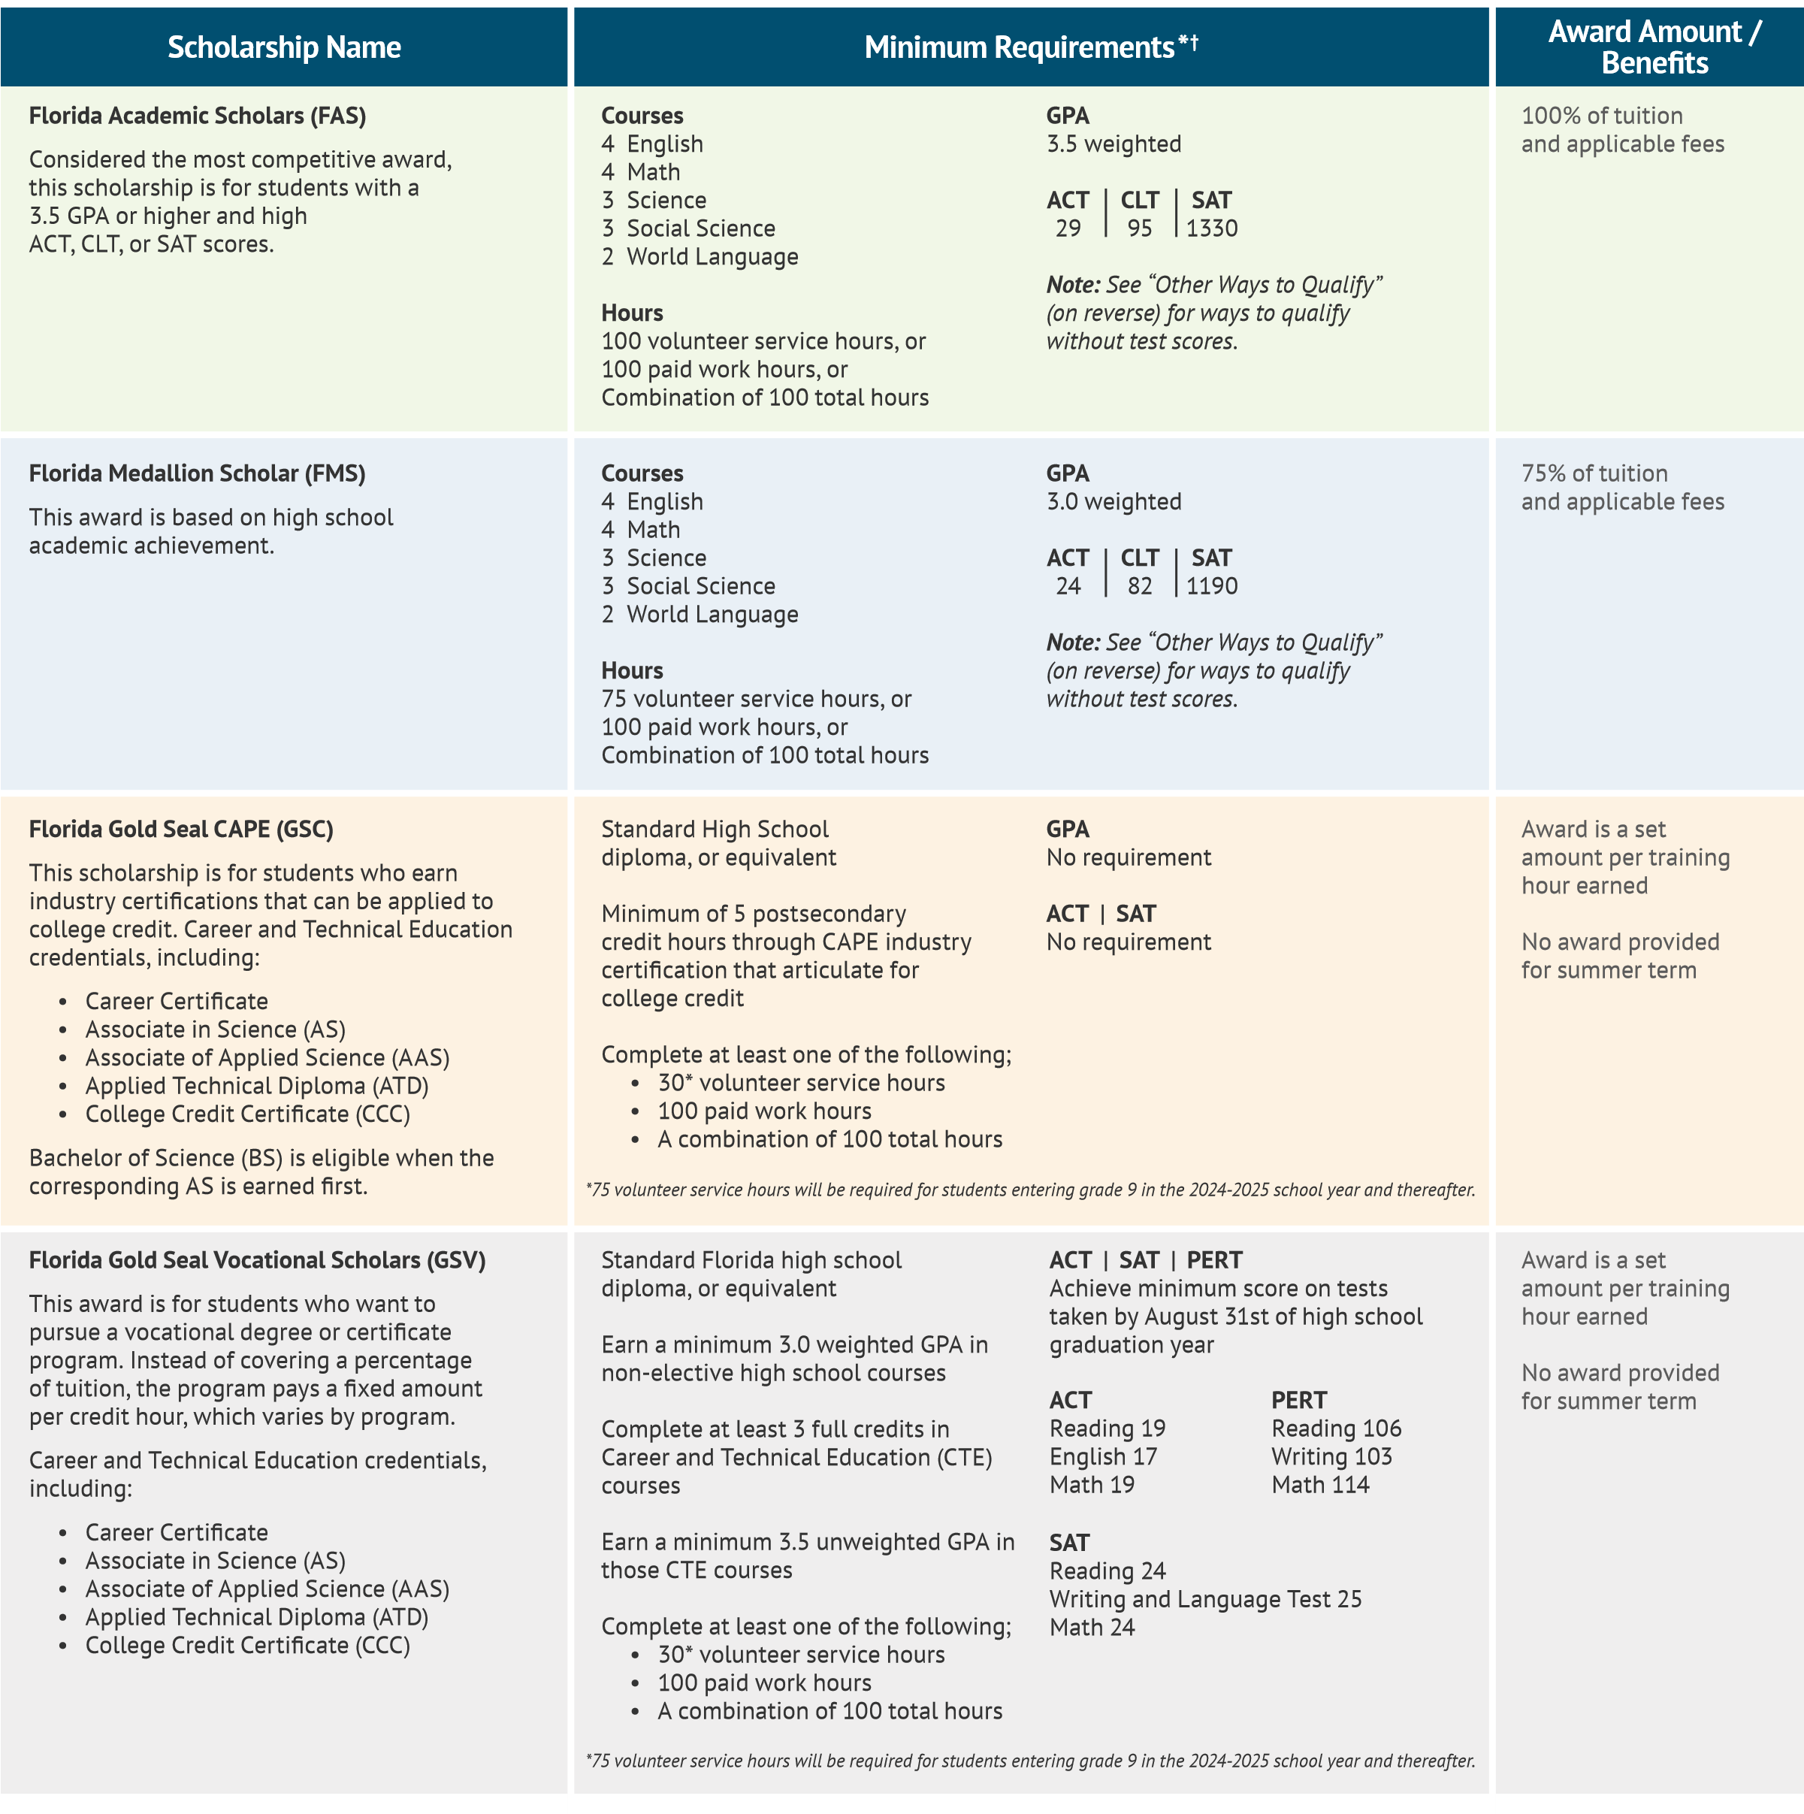
*Eligibility requirements are subject to change with each legislative session
†Different requirements apply to students graduating mid-year and seeking postsecondary funding in the immediate spring. See “Other Ways to Qualify” (on reverse) for details. 7/2025 F

