6TH GRADE Regular MATH SYLLABUS
Mrs. Andux
COHEA 2026-2027
Contact Information:
Email: nandux@coheaedu.com
Room: 204

Teacher Pages: Google Classroom, Remind
There are 4 parent teacher conferences per year. The best way for parents to reach me is by email or Remind.
Course Description: The curriculum for this course aligns with the College and Career Readiness Standards for 6th grade mathematics.
Curriculum: This year, students will be using the following curriculum:
- Florida Reveal Math – Our class textbook. Students will be provided with in-class materials (consumable course book), and have access to digital book as well.
- Students will be using the program i-Ready for diagnostic evaluation throughout three testing periods of the school year. Results will be used to monitor students progress and differentiated instruction.
- IXL is a personalized learning program we will be using to develop mastery of mathematical concepts.

Topics we will cover:

Ratios and Proportional Relationships ( ‘RP’ )

Analyze proportional relationships and use them to solve real‐world and mathematical problems.

The Number System ( ‘NS’ )
Apply and extend previous understandings of operations with fractions to add, subtract, multiply, and divide rational numbers.

Expressions and Equations ( ‘EE’ )
Use properties of operations to generate equivalent expressions.
Solve real‐life and mathematical problems using numerical and algebraic expressions and equations.

Geometry ( ‘G’ )
Draw, construct and describe geometrical figures and describe the relationships between them. Solve real‐life and mathematical problems involving angle measure, area, surface area, and volume.
Statistics and Probability ( ‘SP’ )
Use random sampling to draw inferences about a population.
Draw informal comparative inferences about two populations
Investigate chance processes, and develop, use, and evaluate probability models

Materials:
Students are expected to bring the correct materials each class day. Please refer to the Supply List on the next page.

Classroom Rules: District policies are followed as outlined in the school-wide Student Code of Conduct. Classroom Rules are posted on the bulletin board. Rules are based on a foundation of Honor, Respect, & Loyalty.

The progression of consequences if rules are as follows:
- Verbal warning
- Change in seating assignment
- Detention
- Parent/Teacher Conference
- Office Referral
***In some cases, some or all of these steps may be skipped depending on the level of the offense.

Homework:
Homework is an important part of learning and mastering math concepts. Students should expect to have 30-45 minutes of math homework Monday through Friday in order to reinforce concepts taught during class. Students receive credit for the assignment, provided they show their work, document reasonable effort, and turn the assignment in on time.

Late Homework:
Students are expected to complete assignments on time. In the event of an absence, it is the student’s responsibility to check with his/her class buddy or teacher for missed work and notes or check Google classroom for more information.
- If there are extenuating circumstances that caused the assignment to be late, parents should email me to make arrangements. Always, check my teacher page and Google classroom for posts and updates.

Grading:
We follow the District Grading Policy. The grading scale is as follows: 100% - 90% — A
89% - 80% — B
79% - 70% — C
69% - 60% — D
59% or below — F

Weighted Grading Scale:

- 35% Assessments
- 20% Quizzes
- 15% Classwork
- 5% Homework based on effort, work shown, neatness and completeness
- 25% Projects & Cooperative Presentations

- COHEA incorporates an academic ‘zero policy’, which refers to a zero-tolerance policy for dishonest (‘cheating’) or missing work. Assignments will not be accepted that do not meet minimal standards of completion and honesty.
- On all assessments given by the teacher, there is no minimum grade (ex. Receiving a C despite not earning a satisfactory mark). Students will receive the grade that they earned on the assessment.
- Any assignment that is not submitted by the end of the unit of study or two weeks prior to the end of the semester (teacher discretion), will remain a zero in the grade book.
- Homework must be “on-time” (ready at the beginning of class, neat and COMPLETE).
- All written assignments need to be done in pencil.
- All supporting work must be shown for each problem. Please be prepared to explain your work during homework review time.
- Work must be properly labeled with your name, date, period, and assignment title before being turned in.
- Extra credit will not be available.

“Zero Work” (Z):

If the student receives a “Z” in the gradebook, it means the student did not do the assignment.
- The student can turn in the assignment late for a lower grade. In these extraordinary cases, the student has a maximum of 1 week in order to turn in a late assignment.
- If the student has 3 or more “Z”s with no doctor’s note then they will earn a call home and possibly detention.

Interactive Notebook (INB) Guidelines:
- Students must have their Interactive Notebook (INB) every day to organize and record their work, refer to vocabulary and personalized notes, and keep track of future assignments.
- Table of Contents and Notes must be kept current, dated, labeled, and page-numbered.
- Students will grade work and complete corrections in pen
- INBs will be randomly collected and reviewed without notice for neatness and note checks.

Plagiarism/Academic Integrity:
Academic integrity is expected on all assignments. Plagiarism is defined as presenting the work of another as one’s own. Cheating on an assignment or assessment is another activity that violates ethics and school rules. Any work that exhibits cheating/plagiarism, will result in a zero, parental notification, and disciplinary action may be taken.

Mrs. Andux’s Materials List
WRITE YOUR NAME ON ALL YOUR BELONGINGS
so they can be returned to you!
LOST ITEMS ARE THROWN AWAY AT THE END OF THE YEAR!
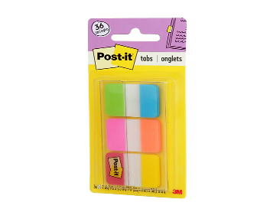
- 1 pack of college rule paper
- 2 expo/dry-erase markers – intensive class only
- 1 composition notebook (any color)
  - (2 TOTAL only if you have intensive math)
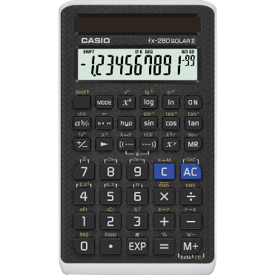
- (1) 12-inch metric/standard ruler
- Post it tabs (not flags)
- Casio fx-260 Solar II calculator
- 1 box of tissues
- COHEA-APPROVED jacket (please write your name in permanent marker on the inside!)
- pencil pouch with zipper  - mechanical pencils and your own lead  - #2 pencils  - highlighters  - pens (any color)  - covered pencil sharpeners  - eraser  - glue stick  - scissor  - colored pencils  - sharpie (at least one, in any color)  - 1 Raincoat and/or umbrella | These items should be in a zippered pencil pouch (not a plastic one) and can be shared with other teachers and subjects.  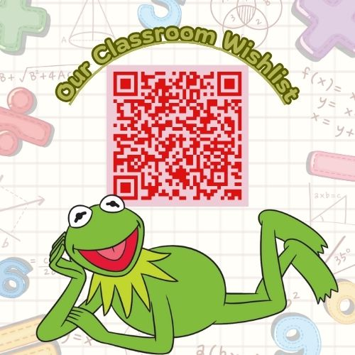  Students are responsible for having these materials every day!

Please sign and return to Mrs. Andux
*Parents/Guardians, please indicate (circle/star/checkmark/etc.) the best way to contact you below.

Students Name: ______________________________________ Period: ________

Student cell phone: _______________________________________

Guardian’s Name: _________________________________________

Relationship: ____________________________________________

E-mail Address: __________________________________________

Cell Phone: _____________________________________________

Please sign that you have read and understood what is expected of your child for this new school year. Thank you.
Student Signature
_____________________________________

Parent/Guardian Signature
_____________________________________

