Mrs. Andux’s Materials List
WRITE YOUR NAME ON ALL YOUR BELONGINGS
so they can be returned to you!
LOST ITEMS ARE THROWN AWAY AT THE END OF THE YEAR!
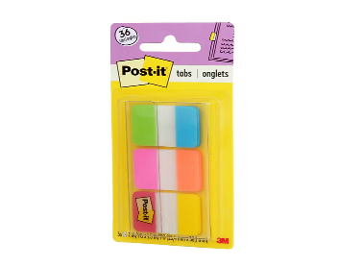
- 1 pack of college rule paper
- 2 expo/dry-erase markers – intensive class only
- 1 composition notebook (any color)
  - (2 TOTAL only if you have intensive math)
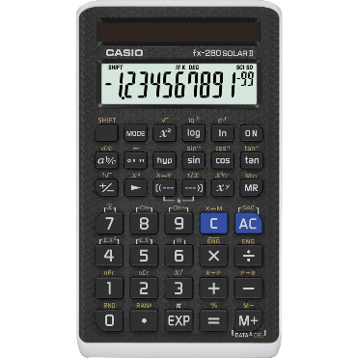
- (1) 12-inch metric/standard ruler
- Post it tabs (not flags)
- Casio fx-260 Solar II calculator
- 1 box of tissues
- COHEA-APPROVED jacket (please write your name in permanent marker on the inside!)
- pencil pouch with zipper  - mechanical pencils and your own lead  - #2 pencils  - highlighters  - pens (any color)  - covered pencil sharpeners  - eraser  - glue stick  - scissor  - colored pencils  - sharpie (at least one, in any color)  - 1 Raincoat and/or umbrella | These items should be in a zippered pencil pouch (not a plastic one) and can be shared with other teachers and subjects.  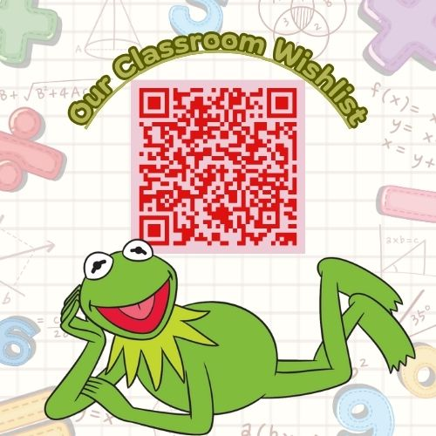  Students are responsible for having these materials every day!

