CITY OF HIALEAH

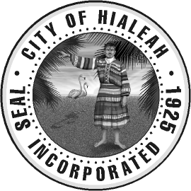

NOTICE OF CANCELLATION
OF THE OF THE OCTOBER 25, 2022 CITY OF HIALEAH CHARTER SCHOOL OVERSIGHT COMMITTEE

DATE: TUESDAY, OCTOBER 25, 2022

TIME: 6:30 P.M.

PLACE: HIALEAH CITY HALL
501 PALM AVENUE
3RD FLOOR COUNCIL CHAMBERS
HIALEAH, FLORIDA 33010

Should you have any questions or concerns please contact the Office of the City Clerk at (305) 883-5820.

